**18CSC301T -Formal Language and Automata Theory**

**Worksheet 4 – Unit 1, Sessions - S7 and S8**

**Topics:** ∈**-NFA and NFA equivalence, DFA-NFA equivalence, DFA minimization.** Part – A

1. A language if accepted by DFA, will be accepted by the equivalent NDFA also. Justify your answer. 2. If a NFA has n states, the the corresponding DFA has _____ states

3. In Qx∑ = P(Q), the power set of Q has a maximum of __________ elements for a DFA and _____________ elements for a NFA.

4. For NFA with epsilon moves, which of the following is correct?

a) ∂ : Qx∑ = P(Q)

b) ∂ : Qx (∑ U ∑+) = P(Q)

c) ∂ : Qx(∑+) = P(Q)

d) ∂ : Qx(∑ U ∈) = P(Q)

5. The final state(s) of a NFA converted from the corresponding ∈-NFA is

a) same final state as ∈-NFA

b) ∈-closure (final state of NFA)

c) All states that can reach the final state of ∈-NFA only by seeing an ∈

d) final state as the corresponding MDFA

Part – B

1. Convert the below NFA to a DFA with minimal states.

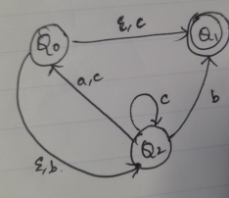

2. Given L1=01* and L2 = 0*1, M1 and M2 are the machines recognizing L1 and L2 respectively as shown in the figure below, design automata recognizing L1 U L2, L2 and L1*.

3. Find the epsilon closure(1) in the following ∈-NFA.

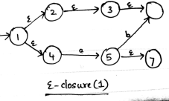

4. Convert a DFA that accepts binary number 9 to a NFA that accepts both binary equivalents of both the numbers 5 and 9.

5. Convert the ∈-NFA in the below figure to a NFA .

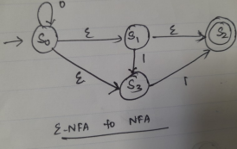

6. Check whether the below DFA is minimized, if not minimize it.

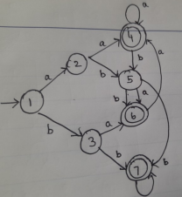

7. Find the minimum state DFA accepted by the following ∈-NFA.